**React and Java Application configuration**

Java spring boot Application Configuration:

1. Install java 8 and maven
   1. <https://www.tutorialspoint.com/maven/maven_environment_setup.htm>
2. Install eclipse
3. Import project as existing maven project
4. Create my sql table in database by using wamp or xamp server
5. 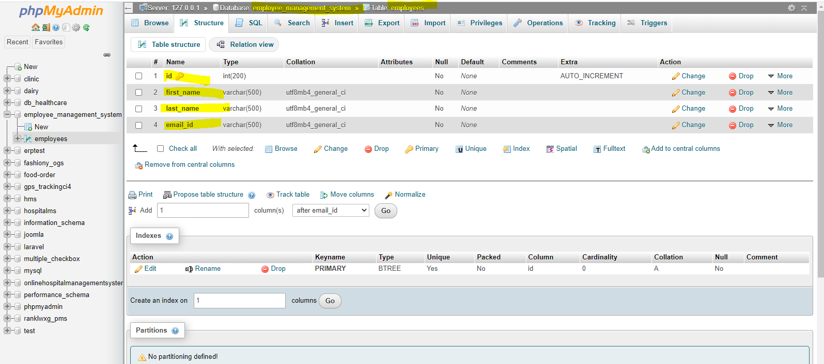
6. Right click on applicatoion and click on maven build give command as ‘clean install’ in goal and clikc on run
7. 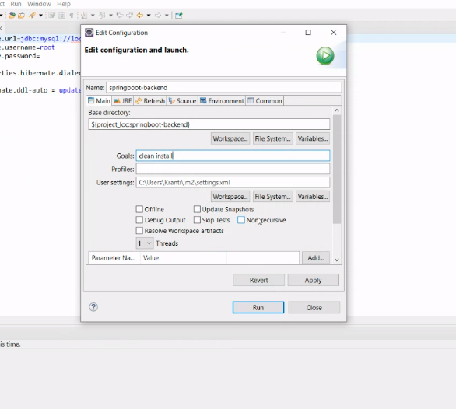
8. Right click on project and click on “run as spring boot application” or “run as java application”

Start React application

1. Open folder in VS code
2. npm install
3. npm start
4. application start st localhost:3000